March 24, 2026

Thank you for attending the Public Hearing Open House for the proposed widening of Bomar Road and extension of Lee Road, PI Number 0019889. Our goal is two-fold: 1) to provide you with information on the proposed project and 2) to provide an opportunity for you to give us your comments on the proposed project and environmental document. In this handout package, you will find a description of the project, a location map, summary of environmental study statement, right-of-way acquisition statement, and a comment card.
As you enter the room, please take a look at the project display. Douglas Count Department of Transportation (DOT) and Georgia DOT representatives, wearing nametags, are available to discuss the project and answer your questions. There will be no formal presentation.
We hope you will take the opportunity to tell Douglas County what you think. Listed below are several ways to comment on the project. Your comments are important to us and, should you provide comments by one of the methods noted below, we will respond to you in writing usually within 30 days of the close of the comment period. All comments will become part of the project’s official record.
While you are attending the open house, you can provide your comments today by filling out the comment card provided with this handout and dropping it in the comment box or you may choose to provide your verbal comments to the court reporter who will transcribe your comments.
You can also provide your comments by Friday, April 03, 2026 by using any of the following methods:
- Online at https://www.douglascountyga.gov/894/0019889-Lee-Road-Extension-from-SR-92-to
- Mail in your comment card to Suleman Rana, Douglas County DOT, 4655 Timber Ridge Drive, Douglasville, Georgia 30134.

The project displays and plans will be available for review for ten days after this open house at the website noted above. Hardcopies will also be available at the Douglas County DOT office located at 4655 Timber Ridge Dr, Douglasville, Georgia 30135. Following the ten-day public comment period, a copy of all comments received will be available by request at the address listed above.
Again, thank you for attending this open house. If you should have any questions or need additional information, feel free to contact the Douglas County DOT project manager, Jack Burnside, at jburnside@douglascountyga.gov (678-449-3972) or the Georgia DOT environmental analyst, Sydney Feldt, at sfeldt@dot.ga.gov (404-800-0583) of the Office of Environmental Services.


Sincerely,

Suleman Rana, MS, P.E
Managing Director
Douglas County Department of Transportation

Why We Are Here: This project is needed to improve connectivity and access within the central part of Douglas County by widening Bomar Road and extending Lee Road. The primary Purpose of the proposed project is to improve connectivity and access within the central portion of Douglas County by extending Lee Road to Bomar Road on a new location, providing an important county-wide east-west connector with greater access to major corridors like Interstate (I) 20. Secondary benefits of the proposed project would include congestion relief to State Route (SR) 92 by diverting traffic flow to Lee Road and Bomar Road utilizing the new location, and operational and safety improvements for the increased volume of motorists going to and from I-20 or making local trips along the segment of Bomar Road north of Pope Road specifically at the Bomar Road at Pope Road intersection. The project would also provide needed pedestrian infrastructure.
Project Description: The proposed project (PI 0019889) would begin approximately 600 feet south of the intersection of Bomar Road at Pope Road. The Preferred Alternative proposes reconstructing the Bomar Road at Pope Road intersection into a roundabout. Additionally, Bomar Road would be widened to the north approximately 1,550 feet from two 11-foot-wide lanes to four 12-foot-wide travel lanes in each direction, with a 20-foot-wide raised median. From this point along Bomar Road, the project would continue on a new location to the existing State Route SR 92 at Lee Road intersection. The new location section would consist of four 12-foot-wide travel lanes with a 20-foot-wide raised median. The shoulders of the four-lane sections would consist of 16-foot-wide shoulders with a curb and gutter, including a 5-foot-wide sidewalk on the west side. On the east side of the four-lane sections, a 19-foot-wide shoulder with a curb and gutter, including an 8-foot-wide shared-use path, is proposed to be constructed. The proposed right-of-way (ROW) width is 60 to 150 feet. The proposed speed limit is 45 miles per hour (mph). The entire project would be 1.7 miles long.

Project Location Map:

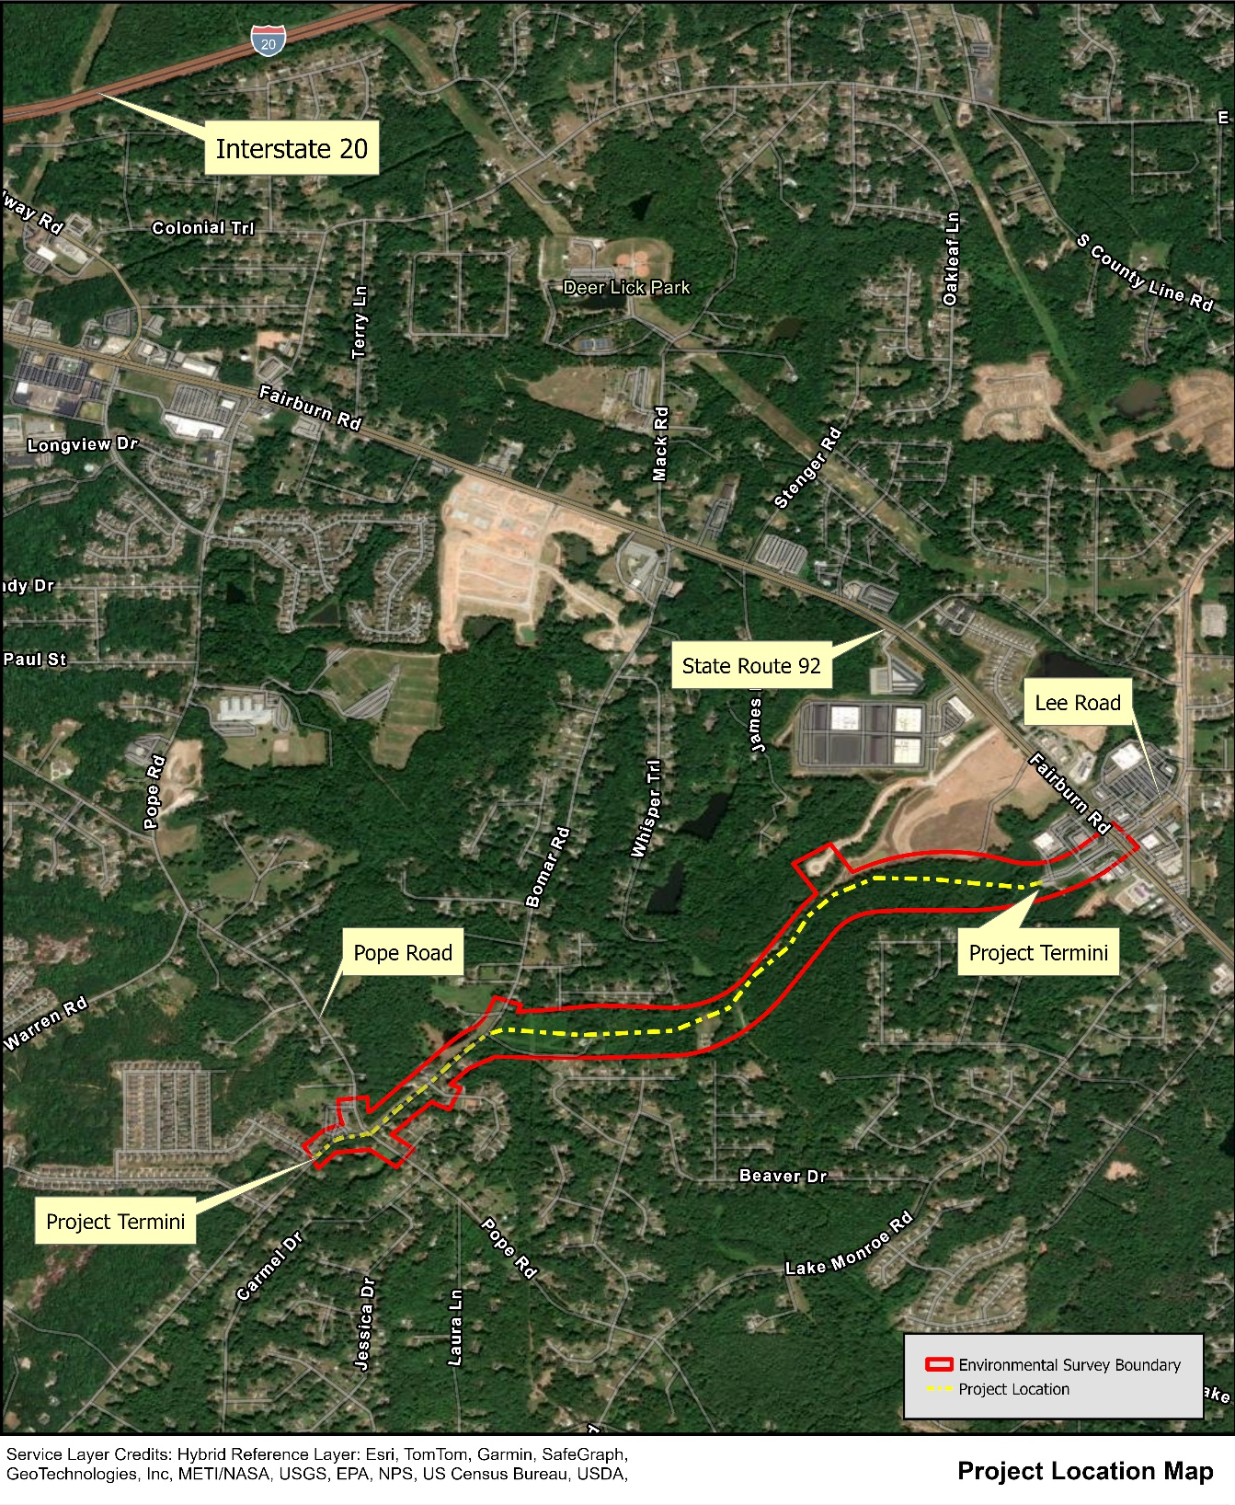

Summary of Environmental Study

In compliance with the 1969 National Environmental Policy Act, the Georgia Department of Transportation has conducted an assessment of the social, economic and environmental effects for the proposed 1.7-mile project beginning approximately 600 feet south of the intersection of Bomar Road at Pope Road. The project proposes reconstructing the Bomar Road at Pope Road intersection into a multi-lane roundabout. Additionally, Bomar Road would be widened to the north of the Pope Road intersection approximately 1,550 feet from two 11-foot-wide lanes to four 11-foot-wide travel lanes, divided by a 3-foot-wide raised median. From this point along Bomar Road, the project would continue on a new location for 1.13 miles to the spur south of SR 92 at Lee Road intersection. The new location section would consist of four 12-foot-wide travel lanes with a 20- foot-wide raised median. The shoulders of the four-lane sections would consist of 16-foot-wide shoulders with a curb and gutter, including a 5-foot-wide sidewalk on the west side. On the east side of the four-lane sections, a 19-foot-wide shoulder with a curb and gutter, including an 8-footwide shared-use path, is proposed to be constructed. The existing ROW is 50 feet wide. The proposed ROW width is 60 to 150 feet. The proposed speed limit is 45 miles per hour (mph). The following information gives a summary of the environmental document.

No residences or businesses would be displaced by the proposed project. The roadway would be placed closer to residences, and loss of yard area would occur. However, owners would be compensated for these losses. Please see the right-of-way acquisition statement on the next page for more information.

In accordance with Executive Order 11990, the proposed project was surveyed for wetland and stream involvement. Two (2) jurisdictional wetlands and five (5) jurisdictional streams were identified within the project’s area of potential effect (APE). It is estimated that 0.099 acre of wetlands and 2,288 linear feet of streams would be impacted by the proposed project. A U.S. Army Corps of Engineers Section 404 permit would be required for this project.

In accordance with Executive Order 11988, the proposed project was surveyed for floodplain involvement. A hydraulic study would be conducted to measure the resulting increases in floodplain and floodway elevations. It is expected that the proposed project would require a Conditional Letter of Map Revision (CLOMR). Elevation increases that exceed .04 foot and width increases that exceed one foot would require the processing of a CLOMR.

The proposed project would not exceed state and federal air quality standards, and it is consistent with the State Implementation Plan for the attainment of clean air quality in the state. The state of Georgia is considered to be in attainment for Particular Matter 2.5 and no further analysis is warranted. During construction, particulates would slightly increase in the corridor as dust from construction collects in the ar. Concurrence with the determination regarding Particulate Matter 2.5 was received on August 8, 2025

The construction of this project would result in a maximum seven decibel (dBA) increase in traffic generated noise by the design year 2050, and no residence would approach or exceed the noise abatement criteria. The project would not result in any substantial noise level increase. Noise increases over 15 dBA are considered substantial. No impacts were identified for this project. Therefore, abatement measures were not considered.

In compliance with Section 106 of the National Historic Preservation Act of 1966, the project has been surveyed for existing and eligible National Register properties. No existing or eligible historic resources were found to be located within the project's area of potential environmental effect. Three (3) archaeological sites of unknown eligibility were found within the project's area of potential environmental effect, however these sites were outside of the project’s construction limits. To further protect these sites, designation of these archaeological areas as an environmentally sensitive area and would be protected with orange barrier fencing (OBF).

The proposed project would affect the following threatened or endangered plant or wildlife species, as six species are located in or frequent the project area. For federally protected species, the project May Affect is Likely to Adversely Affect the tricolored bat (Perimytotis subflavus). For state protected species, the project would have No Significant Adverse Effect for the highscale shiner (Alburnops hypsilepis), Chattahoochee crayfish (Cambarus howardi), pink ladyslipper (Cypripedium acaule), bay star-vine (Schisandra glabra) and Georgia aster (Symphyotrichum georgianum).

In accordance with the Farmland Protection Policy Act, the criteria of 7 CFR, Part 658 have been applied to determine the project effects on farmland. Based on the assessment of these effects, the project would not involve any farmland and no additional alternates need to be examined.

The proposed project has been surveyed for potential sites where contaminated soil and/or water from leaking underground storage tanks may exist. One potential site was identified and investigated. No indication of release or contamination above regulatory thresholds was determined.

Copies of the environmental document are available at this hearing for your review or by request to the Douglas County DOT on the first page of this handout.

Right-Of-Way Acquisition

Results of the field inspection by GDOT personnel have revealed that there will be no residences and no businesses that will be required to relocate.

GDOT has the responsibility, once a project is approved, of appraising, purchasing property and, if required, assisting individuals, families or businesses in relocating. When purchasing property, we desire to pay full market value for the necessary property. This value will be established by using qualified real estate appraisers who will prepare, for GDOT’s use, written appraisals using actual sales data in the surrounding community.

In making an appraisal, the appraiser will contact each property owner and arrange a convenient time to make an on-site inspection of the property with him or her. After completion of the appraisal, the right-of-way appraisal staff will review and field check the findings for accuracy to ensure that all things relating to value have been considered in establishing the amount to be offered. When only a part of the property is needed, we will purchase that part plus pay for loss of value, if any, to the remaining property. In all cases, when GDOT purchases property, we will make additional payments to property owners for the cost of transferring ownership to GDOT. These costs generally include transfer taxes, deed-recording fees, mortgage pre-payment penalties and the pro-rata share of city or county taxes.

Georgia DOT is aware of the problems experienced by individuals, families, businesses, and nonprofit organizations when they are required to move. It is our commitment that no family or individual will be required to relocate until comparable decent, safe and sanitary housing is available or is provided for those occupants.

Additionally, GDOT will provide assistance to businesses and nonprofit organizations in relocating to other sites and will encourage them to remain in the community.

The information pamphlet “What Happens When Your Property is Needed for a Transportation Facility” is available at the greeter’s table. This booklet outlines the services offered and any payments for which you may be eligible, such as moving expenses and replacement housing benefits for owners and tenants. The brochure also outlines the eligibility requirements for receiving these payments.

It is important to remember that GDOT is committed to the principle that no one will be required to relocate until housing is available, or, if there is no housing available, until provisions have been made by GDOT to provide housing. It is also important to remember that all displaces will be given sufficient advance notice of GDOT’s intention to purchase any property in order to allow sufficient time in which to relocate, if applicable.

The GDOT District 7 Office, located in Metro Atlanta, Georgia, 404-559-6699 will be in charge of acquiring the necessary right-of-way for this project.

Comment Card

Please print responses.

Name
Address

Email
Do you support the project as presented? (check your response)
□ For □ Against □ Conditional (I would support this project if… describe below) □ Uncommitted
Comments

Help GDOT Improve Future Meetings:
Advertising: How did you hear about the meeting?
□Newspaper □Signs □GDOT Website □Radio □Word of mouth □Social Media
□Postcard □Other
Attendance: Did you visit the online information for the project? □Yes □ No

Questions | Answer | If the answer is no, please provide a suggestion/comment.
Was the location/website convenient? | □Yes □No
Was the time convenient? | □Yes □No
Were your questions answered? | □Yes □No
Do you understand the project? | □Yes □No
Were materials (in person or virtual) understandable? | □Yes □No

Please share your suggestions on improving the ways GDOT conducts or advertises open houses:

Mail to:
Suleman Rana, MS, P.E.
Managing Director
Douglas County Department of Transportation
4655 Timber Ridge Drive, Douglasville, Georgia 30135

