
PRESS RELEASE

___________________________________________________________________________________________________________

For Immediate Release: Tuesday, September 15, 2020

DOUGLAS COUNTY DUI/DRUG COURT SELECTED AS MODEL COURT

Douglasville, Georgia- Douglas County’s DUI/Drug Court under the leadership of the Honorable Chief Judge Eddie Barker and the Honorable Judge Brian Fortner have been selected by the Council of Accountability County Judges as a Model Court Program for the entire state of Georgia.

“This is a huge honor for our Accountability Court Programs and a testament to the hard work of the staff and treatment team,” said State Court Chief Judge Eddie Barker. “Helping those with substance abuse issues become productive citizens is a benefit to the county and it is also rewarding to see families reunited, broken relationships mended, and trust regained through the work the participants do in the program.”

Douglas County’s DUI/Drug Court was selected based on their commitment and dedication to upholding the state’s DUI court standards and best practices. The service as a Model Court is a great opportunity for Georgia’s accountability courts to continue to collaborate and improve the lives of the participants and communities they serve. The designation will be at most a three-year tenure.

“We have witnessed many lives change since starting the DUI/Drug Court in 2013” said Judge Barker. “As a Model Court, we will be tasked with helping other courts that may need assistance and hopefully, the experience to serve as a Model Court will help us develop even more beneficial ways to serve our clients in the future!”

The goal of Georgia’s Accountability Court Model Court Program, supported by the Council of Accountability Court Judges (CACJ), is to recognize the great work of accountability courts across the state, as well as identify strong programs that may serve as mentors for other courts. Programs identified as “Model Courts” are those that have met and exceeded adherence to Georgia’s Standards as dictated by strong performance on certification and peer review processes.

“Being recognized as a Model DUI Court for the State of Georgia is a tremendous honor and it reflects the hard work and dedication of our entire DUI Court Staff and Treatment Team,” said Judge Fortner. “It is an example of what can be accomplished when so many stakeholders in the criminal justice system step outside of their traditional roles and work together to help people succeed in recovery.”

State Court Chief Judge Barker and Judge Fortner host DUI/Drug Court Graduation ceremonies where strong testimonies are shared by participants who have completed the program. “Our participants are the heart of our program and they work tirelessly to better themselves for their families and their community,” Judge Fortner said. “I am thankful to the Board of Commissioners and all of the accountability court programs here in Douglas County. We are all stronger when we work together towards real solutions.”
-30-

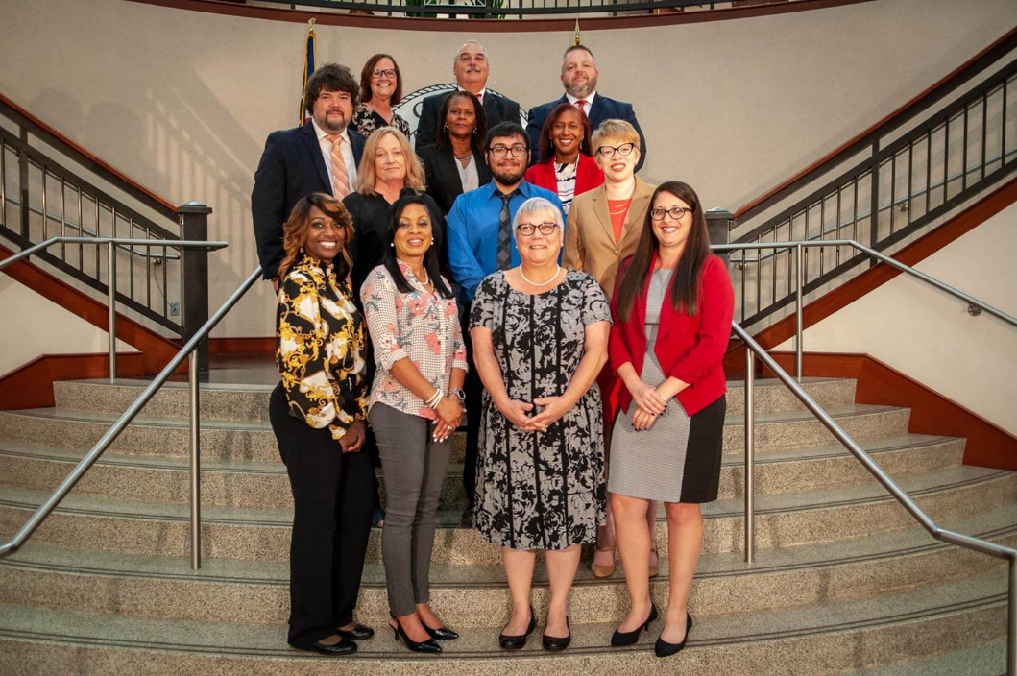
DUI/Drug Court Staff, 2019

